# CS 255 Business Requirements Document Template

Complete this template by replacing the bracketed text with the relevant information.

This template lays out all the different sections that you need to complete for Project One. Each section has guiding questions to prompt your thinking. These questions are meant to guide your initial responses to each area. You are encouraged to go beyond these questions using what you have learned in your readings. You will need to continually reference the interview transcript as you work to make sure that you are addressing your client’s needs. There is no required length for the final document. Instead, the goal is to complete each section based on your client’s needs.

**Tip:** You should respond in a bulleted list for each section. This will make your thoughts easier to reference when you move into the design phase for Project Two. One starter bullet has been provided for you in each section, but you will need to add more.

## System Components and Design

### Purpose

*What is the purpose of this project? Who is the client and what do they want their system to be able to do?*

* Our client is DriverPass, and their purpose in hiring us is to create a web application that will allow them to manage the various components of a driver’s education business, including car time scheduling, test practice, and student progress / management.

### System Background

*What does DriverPass want the system to do? What is the problem they want to fix? What are the different components needed for this system?*

* The problem is that too many people are failing the DMV driving tests. DriverPass wants to capitalize on this by developing a curriculum that will help teach people how to pass the tests, both the written and the practical ones. The following are the components they wish to purchase:
  + Student Management (create, read, update, delete students)
  + Administrative Management (create, read, update, delete admin and employee accounts, reset passwords, etc)
  + Online tests and progress tracking for the students
  + Notes that the teachers can attach to individual students for tracking
  + an area to store any special accommodations needed for the students
  + Photo storage of both driver and student so both can recognize who they should be working with before they have officially met each other (safety concern)
  + Connection to DMV so that the requirements for the tests are always up to date
  + Minimal in house technical maintenance / backups, etc

### Objectives and Goals

*What should this system be able to do when it is completed? What measurable tasks need to be included in the system design to achieve this?*

* Ideally, the system is successful if students are passing the DMV test. We need statistics stored about the ratio of pass-to-fail for students. If more students are failing than are passing, then the system is not working as designed.  
    
  From a technical standpoint, measurable tasks might include test suites to make sure that admins can update all other users, drivers can CRUD notes about students, users can log into the system and see the content for the roles for which they’re assigned, and students can see what times they are assigned for on-the-road driving instruction.

## Requirements

### Nonfunctional Requirements

*In this section, you will detail the different nonfunctional requirements for the DriverPass system. You will need to think about the different things that the system needs to function properly.*

#### Performance Requirements

*What environments (web-based, application, etc.) does this system need to run in? How fast should the system run? How often should the system be updated?*

* The system should be “evergreen” (ie, it is updated / refreshed every time it is ran), pulling the most current information from the DMV about tests and questions.
* It needs to run in a web browser, with offline (ie localStorage / applicationCache) support.
* Obviously, the system should run as fast as the user is able to keep up. It should not run so slowly that the user is waiting for more than 10 seconds per action, nor so quickly that they have cannot keep pace

#### Platform Constraints

*What platforms (Windows, Unix, etc.) should the system run on? Does the back end require any tools, such as a database, to support this application?*

* The backend should run on Linux, and will require a web server, a database, and a language interpreter, like Python, Ruby or PHP.
* The frontend should run on browsers, as a platform. This will ensure that as long as a modern web browser exists for a platform, the application can be used on the platform.

#### Accuracy and Precision

*How will you distinguish between different users?* *Is the input case-sensitive? When should the system inform the admin of a problem?*

* The different users will be distinguished by email-address, and the system will prevent registration of duplicate email addresses.
* Whether the input is case-sensitive will vary by context. Notes will be case-preserved, as will passwords (hashes in the database), but things like username and email address do not need to be case sensitive (nor should they - kkeiper1103 and KKEIPER1103 are the same user)
* Yes, the system should inform the admin(s) of any potential problems.

#### Adaptability

*Can you make changes to the user (add/remove/modify) without changing code? How will the system adapt to platform updates? What type of access does the IT admin need?*

* Yes, it is possible to program the application such that changing user accounts does not need source code access. If you treat the user type as a resource, you can store them in a database and have admins use an interface to manage them.
* There will need to be routine maintenance to make sure that the source code works on the latest version of whichever engine (PHP, Ruby, NodeJS, etc) is powering it.
* Ideally, the admin will need shell access, so the ability to ssh into a box will be most useful.

#### Security

*What is required for the user to log in? How can you secure the connection or the data exchange between the client and the server? What should happen to the account if there is a “brute force” hacking attempt? What happens if the user forgets their password?*

* The user will need to enter their password, which will then be hashed (ideally, via blowfish algorithm). Then the system will retrieve the user account in question and see if the hash of the passwords match.
* Securing the connection can be done by installing an SSL certificate correctly.
* If there is a brute force attempt, the IP should be logged, then blocked. Traffic ideally would be dropped to prevent the attacker from knowing they have been discovered.
* If the user forgets their password, have them enter their email address in a “forgot my password” screen. The application will let them know “if there’s an account registered to the email, we’ve sent a reset password link”, which will then provide the steps to reset the password.

### Functional Requirements

*Using the information from the scenario, think about the different functions the system needs to provide. Each of your bullets should start with “The system shall . . .” For example, one functional requirement might be, “The system shall validate user credentials when logging in.”  
  
The system shall:*

* … provide a method of registering new users
* … provide a method of authenticating existing users
* … provide a method of deactivating accounts
* … provide an administration mechanism to promote certains accounts into administrator capacity
* … provide roles to separate users into Admins, Staff, and Students
* … allow Staff to enter notes about students, as well as tally their progress through the training
* … allow students to check their progress
* … allow students to select the package of help they would like, ie in-car, in-car + 1 lesson, or in-car, in-person lesson & access to all online courses + material.
* … keep the written tests up to date by fetching information from the DMV regularly
* … keep track of available packages, disabling them as the package reaches its capacity limit

### User Interface

*What are the needs of the interface? Who are the different users for this interface? What will each user need to be able to do through the interface? How will the user interact with the interface (mobile, browser, etc.)?*

* The interface needs contextualized per user-type; There are admins, staff, educators and students.
* Admins will need to be able to manage all content within the site, as well as manage users
* Staff will be able to manage student accounts, such as handling registration
* Educators need to be able to see and track notes about the students
* Students need to be able to log in and see their progress, as well as who their instructor is, for safety reasons (making sure they are getting in the right car, etc)
* Users will interact with the application via web browser. Ideally, the site would be designed to adapt to mobile screen sizes, but having had to do this before, this is more challenging than it sounds. If it’s too difficult, then I would design a mobile app, possibly outsource it.

### Assumptions

*What things were not specifically addressed in your design above? What assumptions are you making in your design about the users or the technology they have?*

* One assumption is that the DMV will always provide practice questions / tests
* Another assumption is that the individual users knows how to connect to the internet

### 

### Limitations

*Any system you build will naturally have limitations. What limitations do you see in your system design? What limitations do you have as far as resources, time, budget, or technology?*

* One limitation is that computers with the application “installed” will require internet connection to use the features.
* Another limitation is that this is a small project, for a small company, with a small contractor team. Budget and resources will be limited due to this factor.

### Gantt Chart

*Please include a screenshot of the GANTT chart that you created with Lucidchart. Be sure to check that it meets the plan described by the characters in the interview.*

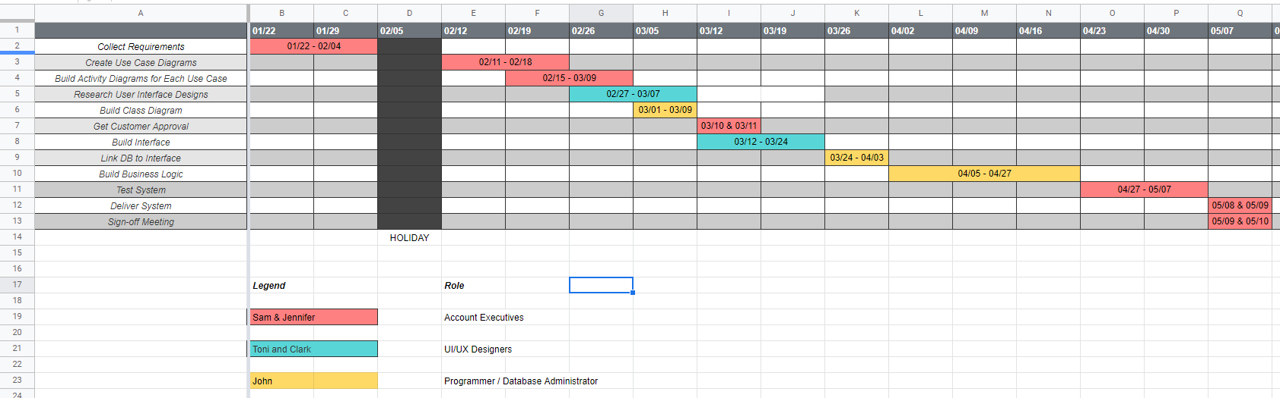

[GANTT Chart DriverPass](https://docs.google.com/spreadsheets/d/1yxcIuRe9YNLudkC_plMb5FJh8gVKq2wRS8h_hSroeGg/edit?usp=sharing)